**CONTENT**

|  |  |  |
| --- | --- | --- |
| **S.No.** | **CONTENT** | **PAGE No.** |
| 1. | Abstract | 2 |
| 2. | Project Overview | 3 |
| 3. | System Design | 4 |
| 4. | Input Design | 8 |
| 5. | Output Design | 8 |
| 6. | Menu Level Description | 9 |
| 7. | Process Specification | 10 |
| 8. | Screen Layouts | 11 |
| 9. | Conclusion | 13 |
| 10. | Bibliography | 14 |

**ABSTRACT**

# The Tour Management System is a modern, user-centric web-based application designed to simplify and automate the entire process of booking, managing, and tracking tours for both customers and administrators. This system replaces traditional manual processes, offering an efficient platform where customers can browse available tour packages, make bookings, and track the status of their reservations. Administrators can manage tour offerings, customer bookings, and payment processing, all through a centralized, easy-to-use dashboard.

# Key features of the system include a structured booking form, real-time updates on tour availability, automated confirmation emails, and the ability to view and manage customer details. Built using modern web technologies such as HTML, CSS, and JavaScript, the system provides a responsive, cross-platform compatible experience, ensuring accessibility for users across various devices.

# The Tour Management System is designed to enhance the customer experience by simplifying the booking process, offering instant confirmation, and providing easy access to tour itineraries. For administrators, the system improves operational efficiency by automating manual tasks, tracking tour availability, and generating reports.

# In conclusion, the Tour Management System offers an efficient and transparent solution for managing and booking tours, transforming the traditional tourism industry by offering a digital solution that improves both customer satisfaction and administrative control. It aligns with the evolving digital transformation in the tourism industry, simplifying processes and enhancing the overall customer experience.

# INTRODUCTION

### PROJECT OVERVIEW

The Tour Management System is a robust, user-friendly web application designed to automate and streamline the entire process of booking, managing, and tracking tours for customers and administrators. By replacing traditional manual booking systems, the platform provides a digital, centralized solution that enhances both user experience and operational efficiency.

The system allows customers to easily browse available tour packages, book trips, and access detailed information such as tour descriptions, prices, itineraries, and availability. Customers can fill out a structured booking form that captures essential details like name, contact information, travel dates, and special requests. Once a booking is successfully submitted, it is processed and tracked in real-time, with users able to monitor the status of their bookings.

Administrators can manage all aspects of the system through a centralized dashboard. They can add new tour packages, view customer bookings, track booking statuses, and handle cancellations or modifications. Additionally, the system enables administrators to view key metrics, such as the total number of bookings, active tours, and revenue generated, helping them make informed decisions and optimize operations.

Built using modern web technologies such as HTML, CSS, and JavaScript, the Tour Management System ensures responsiveness, cross-platform compatibility, and a smooth experience across all devices. The intuitive interface allows both customers and administrators to interact with the system effortlessly, making tour booking and management both efficient and seamless.

The system’s workflow begins with customer registration and tour selection, followed by easy booking submissions. Once the booking is completed, the customer is notified, and the status is updated in real-time. For administrators, the system automates booking processing, reducing the need for manual intervention and ensuring transparency and accuracy in tour management.

In summary, the Tour Management System provides a comprehensive, efficient solution for modernizing the tourism industry. It improves operational productivity, enhances user satisfaction, and allows for future scalability by enabling the integration of additional features such as payment gateways, real-time notifications, and customer feedback systems.

## 2. SYSTEM DESIGN

### 2.1 INTRODUCTION

System design is the process of defining the architecture, components, modules, interfaces, and data structures that collectively fulfill the specified requirements of a software system. It represents the transition from understanding what a system needs to do (as identified in system analysis) to figuring out how to achieve those requirements in a structured and efficient manner. While system analysis answers the “what is” question, system design addresses the “how to” aspect of building or improving a system.

This phase plays a critical role in shaping the success of the project. It involves not only outlining technical solutions but also ensuring that these solutions align with the operational and strategic goals of the organization. System design takes the recommendations from the feasibility study and converts them into a comprehensive blueprint for development, laying the groundwork for the implementation phase.

Before diving into system design, careful planning is essential. It is important to conduct a thorough analysis of the existing system—understanding its limitations, inefficiencies, and pain points—to identify how the new or upgraded system can bring about measurable improvements. This involves evaluating how the integration of computing technologies can enhance overall performance, reduce manual effort, and streamline workflows.

The significance of system design lies in its impact on quality. Design is where the foundation for high-quality software is built. A well-crafted design not only meets user requirements but also ensures maintainability, scalability, security, and efficiency of the system. It acts as a communication bridge between the end-users and the developers by transforming user-oriented documentation into technical specifications that can be interpreted and implemented by programmers, database administrators, and system architects.

Moreover, system design is both a technical and creative endeavor. It demands a blend of analytical thinking, problem-solving, and innovation to architect a solution that is technically feasible, economically viable, and user-friendly. It also includes considering user interfaces, data flows, control logic, and hardware-software integration, all of which contribute to a system that is robust, adaptable, and efficient in meeting its intended purpose.

In summary, system design is not just a step in the development cycle—it is the foundation of a successful and sustainable software product. A strong design ensures that the final system is reliable, efficient, and tailored to meet user expectations and institutional objectives.

### 2.2 INPUT DESIGN

1. **Customer (Tourist):**

* **Booking Form:**
  + **Full Name:** Tourist's full name (text input).
  + **Email:** Tourist's email address (email input).
  + **Phone Number:** 10-digit contact number (numeric input).
  + **Tour Package:** Selected from the list of available tour packages (dropdown).
  + **Travel Dates:** Start and end dates of travel (date picker).
  + **Gender:** Tourist's gender (dropdown).
  + **Number of People:** Numeric input for the number of travelers.
  + **Special Requests:** Additional requests or comments (text area).
* **Validation:**
  + All fields are mandatory.
  + Phone number must be exactly 10 digits.
  + Email must follow a valid email format.
  + Tour package must be selected from the dropdown.
  + Travel dates should be logical (start date must be earlier than end date).

### 2.3 OUTPUT DESIGN

### Customer Outputs:

### Booking Confirmation:

### Popup: On successful submission, a popup appears: “Booking successful. Your tour details have been submitted.”

### Redirection: The user is redirected to a confirmation page or stays on the dashboard displaying the booking status.

### Booking Status:

### After admin review, the status of the booking is displayed as:

### Pending

### Confirmed

### Rejected

### Error Feedback:

### If required fields are missing or invalid, error messages are shown next to specific fields.

### Form submission is prevented until corrections are made.

### Administrator Outputs:

### Tour Booking Review:

### Displays a real-time list of all tour bookings with:

### Customer Name

### Tour Package

### Travel Dates

### Booking Status (Pending/Confirmed/Rejected)

### Action buttons (Approve/Reject)

### Dashboard Overview:

### Displays metrics such as:

### Total Number of Bookings

### Number of Confirmed Bookings

### Number of Pending Bookings

### Number of Rejected Bookings

### Tour Management:

### Displays all active tour packages with details such as:

### Package Title

### Destination

### Tour Dates

### Max. Capacity

### Current Bookings

### Tour Status (Active/Inactive)

### Action buttons (Edit/Delete)

### Error Feedback:

### If there are issues with booking forms or tour details, error messages are displayed to guide the admin in fixing the issue before proceeding.

### This input and output design ensures that the Tour Management System operates efficiently, with clear feedback provided to both the customers and administrators. The design enhances user experience by ensuring the accuracy of information and providing smooth workflow management.

## 3. SYSTEM DEVELOPMENT

### 3.1 MENU LEVEL DESCRIPTION

###### 1. Login Menu:

###### Homepage:

###### The main landing page for users (customers, tour guides, and administrators) to enter their login credentials.

###### Fields: Username and Password.

###### Authentication Result:

###### On successful login, the user is redirected to the appropriate dashboard based on their role (Customer, Tour Guide, or Admin).

###### On login failure, an error popup is displayed indicating incorrect credentials.

###### 2. Customer Menu:

###### Customer Dashboard:

###### Displays a list of available travel packages.

###### Each package entry includes:

###### Package title

###### Destination

###### Package description

###### Price

###### "Book Now" button.

###### Package Booking Form:

###### Allows the customer to book a travel package.

###### Fields include:

###### Full Name

###### Email

###### Phone Number

###### Package Name (selected from available packages)

###### Number of Travelers

###### Travel Dates (departure and return)

###### Includes a Submit Booking button to complete the booking.

###### Form validation ensures all fields are filled correctly.

###### 3. Tour Guide Menu:

###### Tour Guide Dashboard:

###### Displays a list of tours assigned to the guide.

###### Each tour entry includes:

###### Tour title

###### Package details (destination, date, etc.)

###### List of booked customers

###### Current status (upcoming/completed)

###### Tour Management:

###### Allows the tour guide to manage the tours they are leading.

###### Fields include:

###### Tour Name

###### Description

###### Dates (Start and End)

###### Maximum Group Size

###### Status (Active/Completed)

###### Buttons: Create Tour / Update Tour / Delete Tour.

###### 4. Admin Menu:

###### Admin Dashboard:

###### Displays an overview of the system with key metrics such as:

###### Total travel packages

###### Total customers

###### Total tour guides

###### Bookings and revenue statistics

###### Tour Package Management:

###### Displays a list of all available tour packages.

###### Each package entry includes:

###### Package title

###### Destination

###### Price

###### Status (Active/Inactive)

###### Number of available spots

###### Tour Guide information

###### Actions: Edit / Delete

###### User Management:

###### Allows the admin to manage customer and tour guide profiles.

###### Actions include:

###### Add new user

###### Edit user details

###### Delete user profile

###### Fields: Name, Email, Role (Customer/Tour Guide), Password.

###### Booking Management:

###### Allows the admin to view and manage customer bookings for tours.

###### Each booking entry includes:

###### Customer Name

###### Package Name

###### Status (Pending/Confirmed)

###### Actions: Confirm / Reject Booking

###### Feedback Management:

###### Allows the admin to review feedback from customers about tours.

###### Feedback includes:

###### Customer Name

###### Tour Name

###### Rating (1-5)

###### Comments

###### Action: Mark as Reviewed

###### This structure ensures that the Tour Management System is easy to use for customers, tour guides, and administrators while allowing for efficient management of travel packages, bookings, and customer interactions. Each user role has access to features relevant to their tasks, promoting a smooth workflow and enhancing the customer experience.

###### 

### 3.2 PROCESS SPECIFICATION

The Tour Management System is designed to streamline the process of managing travel bookings, customer inquiries, and tour management tasks. The core functionality includes managing travel package offerings, handling customer bookings, and administrative tasks, ensuring system efficiency, minimizing manual effort, and ensuring scalability.

**1. Customer Inquiry Submission:**

**Step1:**  
• The customer accesses the Inquiry Form and fills out the required details:

* **Full Name:** Customer’s name (text input).
* **Email:** Customer’s email address (email input).
* **Phone Number:** 10-digit contact number (numeric input).
* **Travel Destination:** Dropdown selection of travel locations.
* **Travel Dates:** Date picker for departure and return.
* **Gender:** Dropdown for customer gender.
* **Number of People:** Numeric input for the number of travelers.

**Step2:**  
• The system validates the information to ensure:

* All required fields are completed.
* Email follows a valid format.
* Phone number is 10 digits.
* Travel destination is valid and available.
* Travel dates are selected and do not overlap.

**Step3:**  
• Upon successful validation, the inquiry is submitted, and a success message is displayed:

* Success Popup: “Inquiry submitted successfully. Our team will contact you soon.”

**2. Travel Package Display (Customer View):**

**Step1:**  
• After login, the customer is directed to the Tour Package Dashboard where available tour packages are listed.

**Step2:**  
• The system displays the following details for each package:

* Package Title
* Destination
* Package Duration
* Price
* “Book Now” button for booking the package.

**Step3:**  
• The customer can click the "Book Now" button for the selected package to submit their booking request.

**3. Booking Review (Admin View):**

**Step1:**  
• The administrator accesses the Admin Dashboard to review and manage all tour package bookings.

**Step2:**  
• The system retrieves and displays all bookings in a table or card format, including:

* Customer Name
* Package Title
* Booking Status (Pending, Approved, Rejected)

**Step3:**  
• The administrator reviews each booking and updates the status:

* Approve or Reject the booking.
* Update the status and notify the customer via email or dashboard alert.

**Step4:**  
• Upon updating the status, the customer is notified by email or dashboard alert with the result of their booking application (Approved/Rejected).

**4. Package Management (Admin View):**

**Step1:**  
• The administrator can manage travel packages, including adding, updating, or removing them.

**Step2:**  
• Travel package details include:

* Package Title
* Package Description
* Destination
* Duration
* Price
* Available Seats
* Package Status (Active/Inactive)

**5. Access Control:**

**Step1:**  
• Only authenticated users (customers and administrators) can access the system.

* Customers can inquire about packages, submit bookings, and track booking statuses.
* Administrators can manage packages, bookings, and user accounts.

**Step2:**  
• Unauthorized users (non-registered) are restricted from accessing any sensitive data or features of the system.

**6. System Maintenance and Scalability:**

**Step1:**  
• The system supports future improvements such as:

* Adding new tour packages.
* Modifying booking processes and details.
* Integrating online payment gateways for booking payments.

**Step2:**  
• Future enhancements may include:

* Real-time notifications for booking status and special offers.
* Mobile app integration for easy access and management.
* Analytics and reporting for administrators to track booking statistics, customer preferences, and performance.
* Integration with third-party services for hotel bookings and flight management to offer comprehensive travel solutions.

This process specification for the Tour Management System ensures the system operates efficiently, minimizes manual work, and offers scalability for future growth in both functionality and user experience. It simplifies the travel booking process for customers, while enabling administrators to manage the system effortlessly.

**4. SYSTEM TESTING**

* 1. **SCRREEN LAYOUTS**

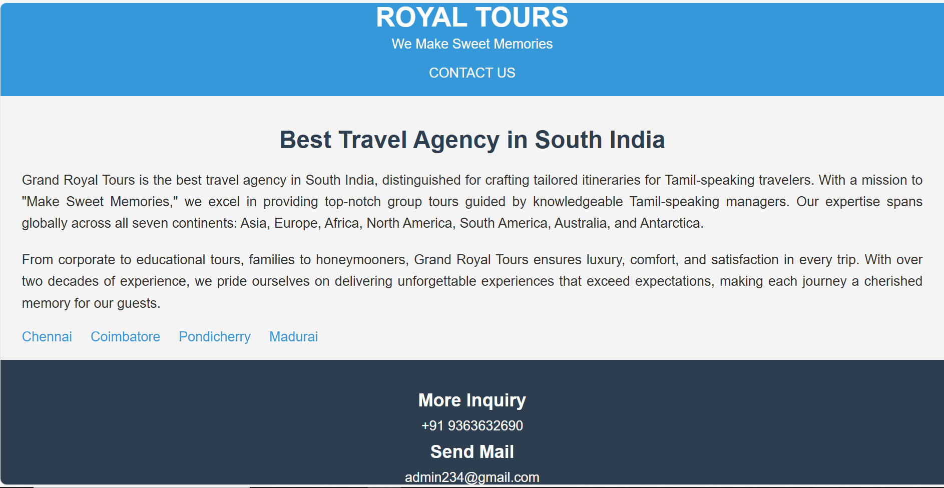

About Us - Travel Agency Overview

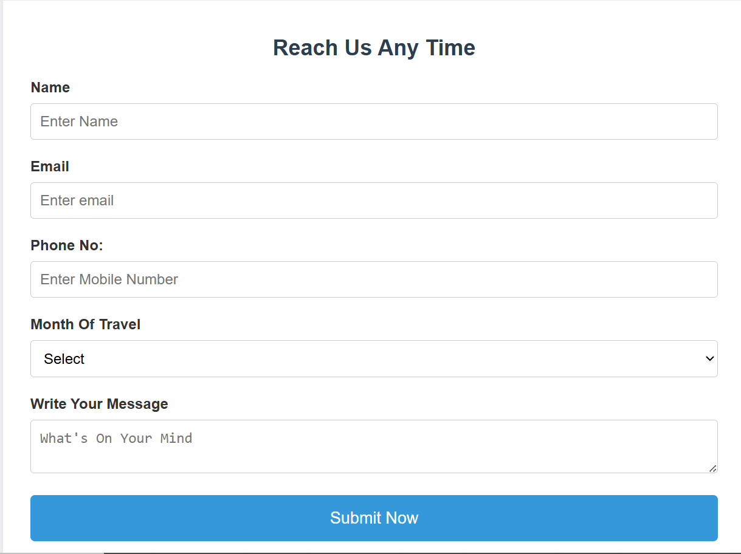

Contact Us Form

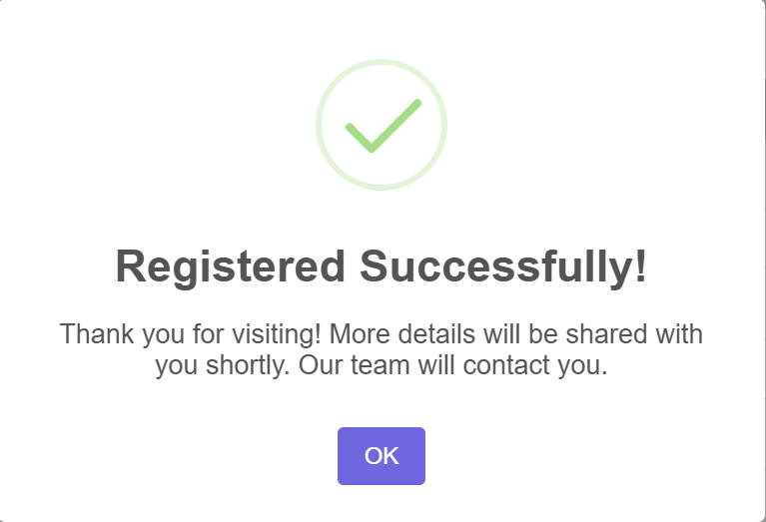

Registration Successful Confirmation

## 5. CONCLUSION

## The Tour Management System proves to be a vital tool in modernizing and simplifying the entire travel booking process for customers and administrators alike. By offering an integrated digital platform, the system facilitates the smooth management of travel packages, customer inquiries, and reservations, ensuring a streamlined workflow for tour agencies. The ease of access to information, the ability to request details about various travel packages, and the simplified booking process provide a satisfying user experience for potential customers.

## For administrators, the system centralizes crucial information, making it easy to manage customer data, monitor bookings, and respond to inquiries in real-time. The automated processes reduce the dependency on manual tasks, minimize errors, and offer better tracking and reporting capabilities. The system’s clear and concise user interface encourages efficient management of data, which helps agencies improve their customer service and optimize their operations.

## Furthermore, the integration of key features like the inquiry form, booking confirmations, and the option to update traveler information enables personalized service, strengthening the agency's relationship with its customers. The ability for customers to contact the agency directly via a messaging feature enhances customer engagement, creating a more responsive and interactive service environment.

## In terms of future growth, the system is designed to scale. As customer demands evolve and the business expands, the platform can be enhanced with additional functionalities such as payment gateways, real-time booking updates, mobile app integration, and advanced analytics for performance tracking. The potential to add new travel packages and destinations further contributes to the system's adaptability to meet the changing needs of the travel industry.

## 6. BIBLIOGRAPHY

1. OpenAI: "GPT-3: Language Models for Text Generation." https://[www.openai.com](http://www.openai.com/)
2. GeeksforGeeks: "Computer Science Portal." [https://www.geeksforgeeks.org](https://www.geeksforgeeks.org/)
3. YouTube: “Various Tutorials and Educational Content." https://[www.youtube.com](http://www.youtube.com/)